Report on

NS2 Offline

Md. Nazmul Islam Ananto

1805093

Introduction:

This assignment wanted us to focus on the outcomes of varying parameters on some specific set of rules. I was assigned –

* MAC type **802.11**
* Routing Protocol **AODV**
* TCP Congestion Control Protocol / Agent type **TCP Tahoe**
* Service / Application **Telnet**
* **Grid** Type Topology
* **One Source** and **Random Sink** for each flow

First let get introduced with the MAC type, Routing protocol, Agent Type, Application used here.

802.11:

IEEE 802.11 is a set of standards for wireless local area network (WLAN) computer communication. It is commonly referred to as Wi-Fi. The 802.11 standards define the technology for wireless communication in the 2.4, 3.6, 5, and 60 GHz frequency bands. The most widely used standard is 802.11b/g/n, which operates in the 2.4 GHz band and provides data transfer speeds of up to 600 Mbps. The latest standard, 802.11ax (also known as Wi-Fi 6), provides faster speeds, improved performance in crowded environments and support for more devices.

AODV:

Ad-hoc On-demand Distance Vector (AODV) is a routing protocol for mobile ad-hoc networks (MANETs). A MANET is a type of wireless network where nodes can move freely and frequently, and there is no fixed infrastructure or centralized network control. AODV is a reactive routing protocol, which means that it only establishes a route between nodes when it is needed to transmit data.

AODV works by having each node maintain a routing table that stores information about the next hop towards a destination. When a node wants to send data to another node, it first checks its routing table to see if it already knows a route. If it doesn't, it broadcast a route request (RREQ) packet to its neighboring nodes. The RREQ packet contains the address of the destination node. The nodes that receive the RREQ packet check their routing tables and forward the packet to their neighbors.

When the RREQ packet reaches the destination node or a node that knows a route to the destination, it sends back a route reply (RREP) packet, which contains the route to the destination. The node that initiated the RREQ then updates its routing table and can start sending data to the destination.

AODV is known for its simplicity and low overhead, making it suitable for resource-constrained devices, and dynamic topologies.

TCP Tahoe:

TCP Tahoe is the first version of the Transmission Control Protocol (TCP) congestion control algorithm. It is named after the location of the first test network on which it was implemented, at the University of California, Berkeley.

TCP Tahoe uses a mechanism called slow start to control the amount of data that is sent over a network connection. When a connection is first established, the sender starts by sending a small number of packets (typically one). If these packets are acknowledged by the receiver, the sender increases the number of packets it sends in the next round. This process continues until the sender receives a packet loss indication from the network.

When packet loss is detected, TCP Tahoe enters a state called congestion avoidance. In this state, the sender reduces the amount of data it sends and uses a mechanism called a retransmission timeout (RTO) to determine when to retransmit lost packets. The sender also uses a mechanism called a congestion window (cwnd) to control the amount of data that can be in transit at any given time.

TCP Tahoe is considered to be less effective in handling high-speed and high-bandwidth networks due to its slow start mechanism and lack of effective congestion control. Therefore, it was replaced by TCP Reno, which provides a more efficient congestion control.

Telnet:

Telnet is a protocol that allows users to connect to and control remote computers over a network. It is based on a client-server architecture, where the client (typically a terminal or a computer) runs Telnet software to connect to a remote server, and the server runs a Telnet daemon to accept connections.

Once a connection is established, the user is able to interact with the remote server as if they were physically sitting in front of it. This includes running commands, editing files, and accessing resources on the server. Telnet uses a plaintext protocol, meaning that all data, including login credentials and commands, are transmitted in clear text format which can be intercepted and read by anyone on the network.

Telnet was one of the first remote access protocols and was widely used in the early days of the Internet. However, due to its plaintext nature, it is now considered insecure and has been replaced by more secure protocols such as SSH (Secure Shell) for remote access. Telnet is still used for network troubleshooting and for connecting to network devices like routers, switches, etc.

Graphs:

* 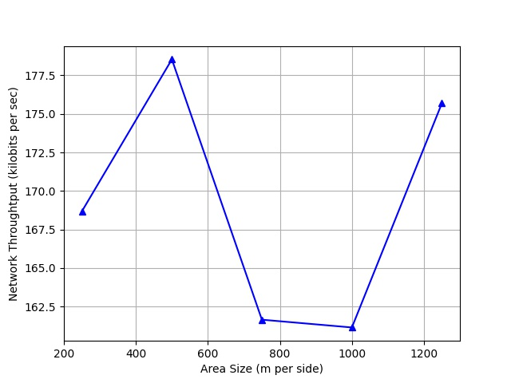Varying area size

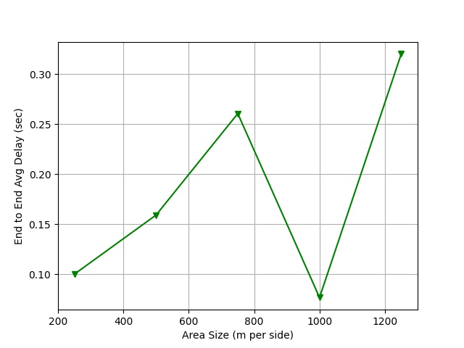

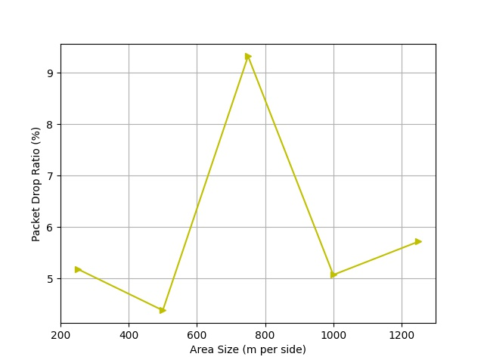

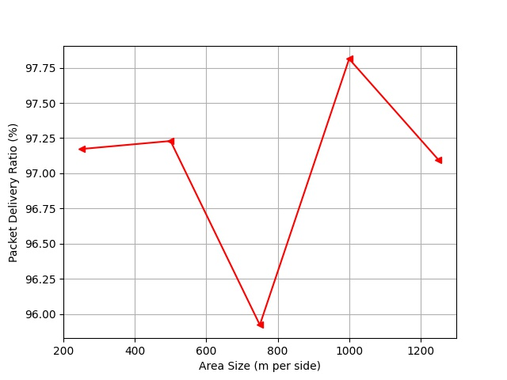

* Varying number of mobile nodes

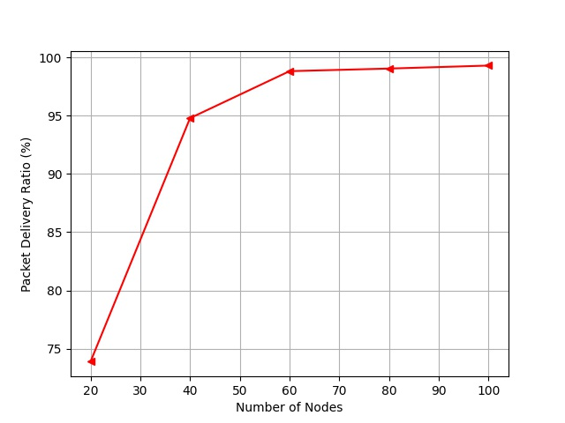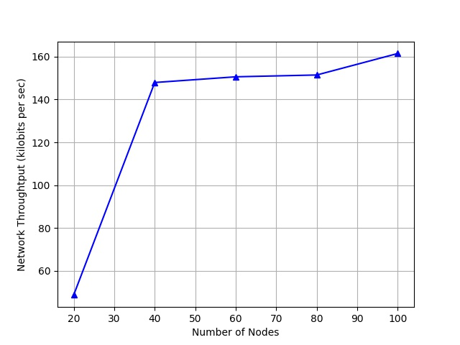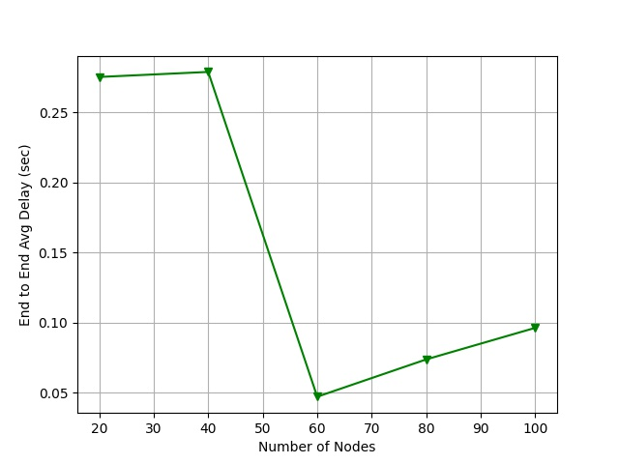

* 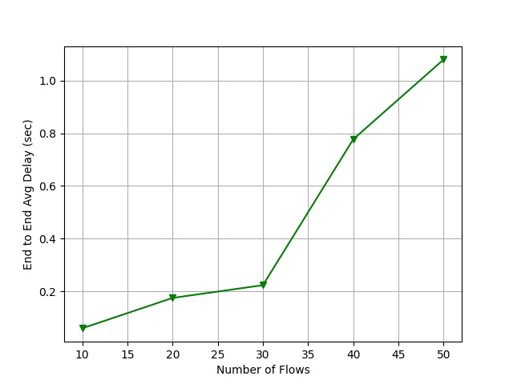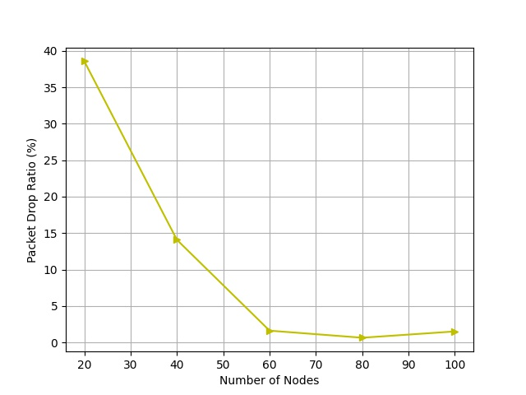Varying number of flows

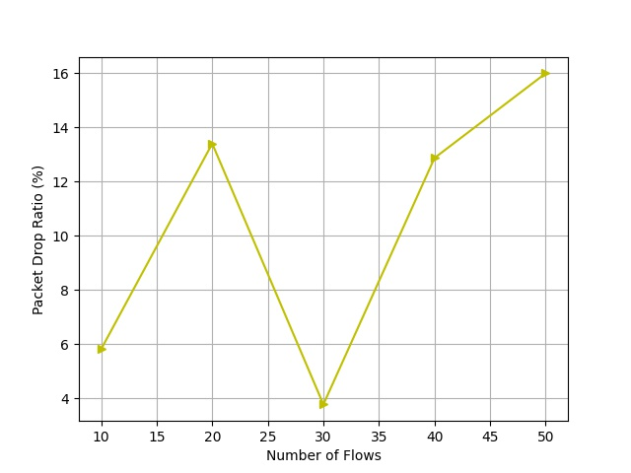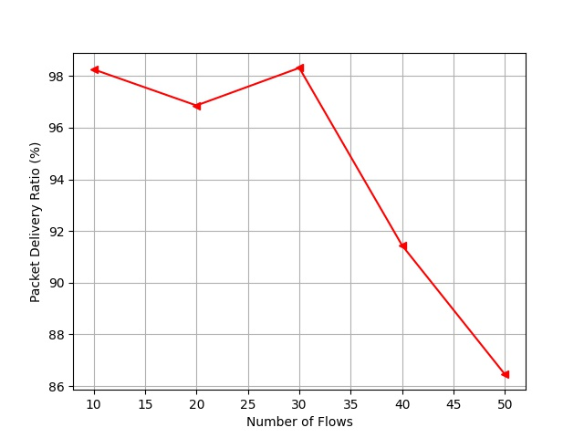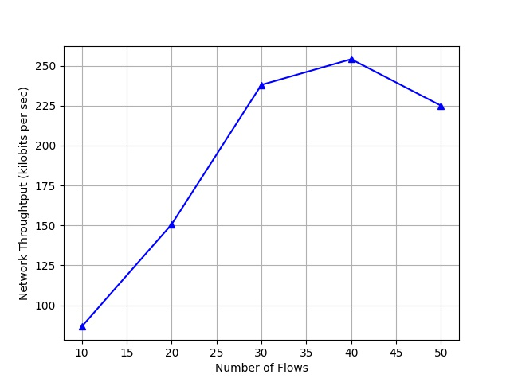

Observations:

* Random movement of the nodes results in irregularity in packet transmission.
* Fewer number of nodes ensures a somewhat less packet drop ratio.
* The more the area size, the more the delay.
* Interestingly, on our short test cases, packet drop ratio decreases while number of nodes increase.
* Increase in number of nodes, increased throughput.